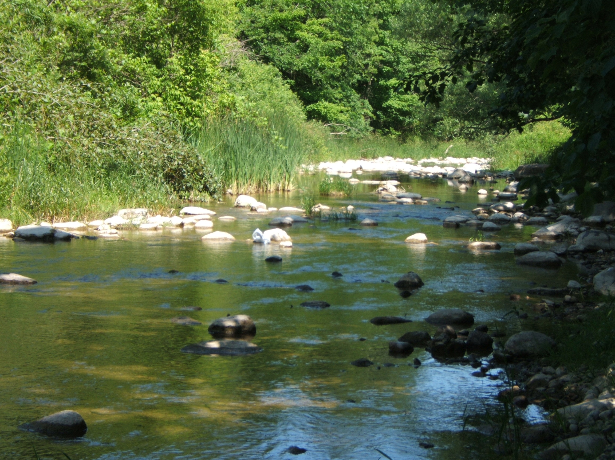
The brook laughs and ripples
Its sound so sweet,
Sun plays on stones and reeds,
With wondrous brush, it paints
A pattern, never, to repeat.
The butterfly on fragile wing,
Is beckoned by the breeze,
It dances high, aloft the stream,
Where summer birds now sing.
My feet on trails familiar tread,
My memories with ease,
Are drawn ,from hidden wells they ebb
For me, to cherish once again,
Like fine pearls on a thread.
Oh wishes could I make, amen,
Please, let this moment never end.
J.W.

